- Clone Git
git clone https://github.com/QualSha/rosypinna_web_v2.git
- Buat Virtual Env.
conda create --name rpl_v2 python=3.12
- Instal Semua Paket Python
pip install -r requirements.txt
- Buat DB di Localhost
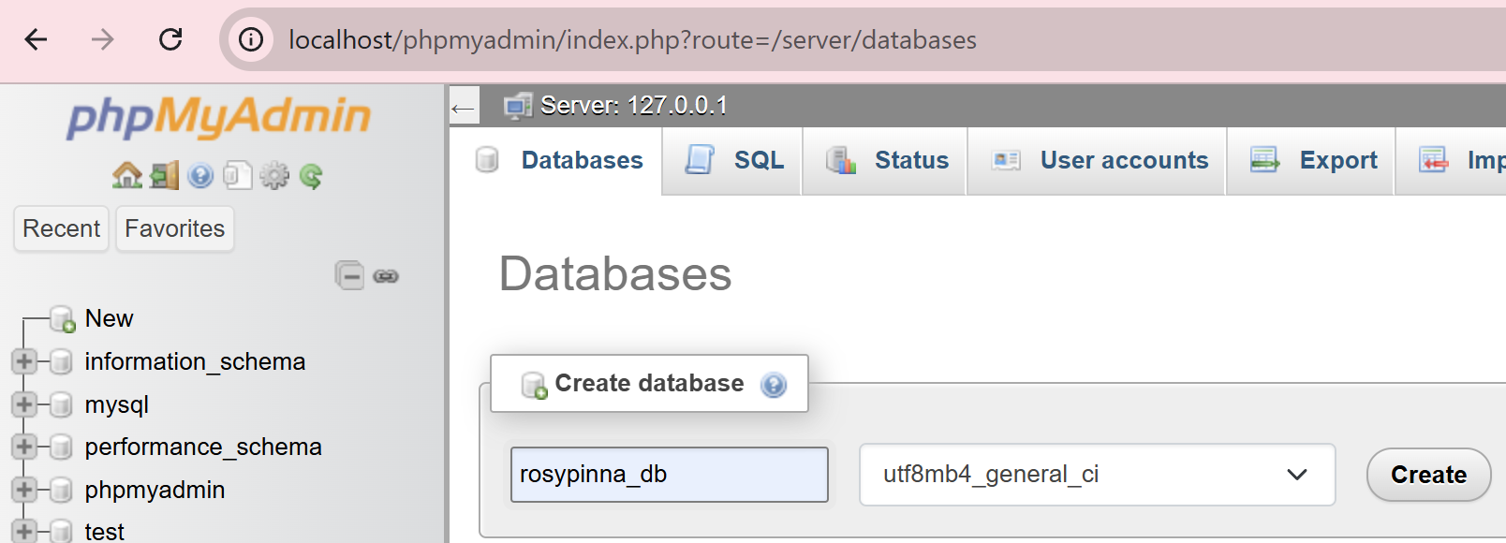
visdat8_db
- Ubah my.ini
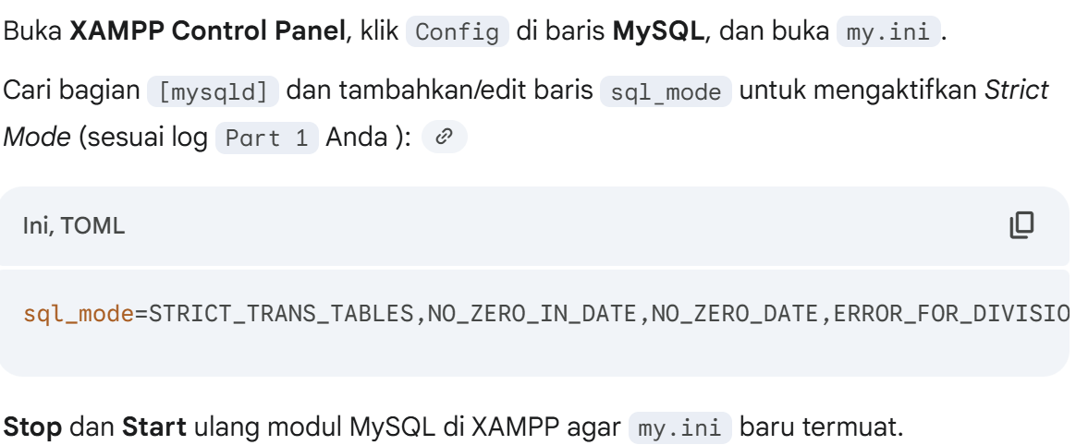
sql_mode=STRICT_TRANS_TABLES,NO_ZERO_IN_DATE,NO_ZERO_DATE,ERROR_FOR_DIVISION_BY_ZERO,NO_ENGINE_SUBSTITUTION
- Start Server dan Jalankan Migrasi Database
python manage.py migrate
- Install Dependensi Front End (NPM)
python manage.py tailwind install
- Start Server
Terminal 1: python manage.py runserver
Terminal 2: python manage.py tailwind start

